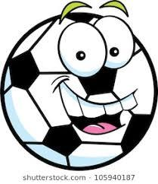
The Specials Challenge

Music  Create your own musical instrument. Here are some ideas:  https://artsycraftsymom.com/diy-musical-instruments-for-kids-to-make-and-play/ | Technology  Scavenger Hunt  Find and list all pieces of technology you can find in your house. | Library  Read outside for 20 minutes. | PE  GO OUTSIDE!  Try Hopscotch, riding your bike, skateboarding, Monkey in the Middle | Music  Make up a dance to your favorite song. EXTRA POINTS if you record a video of you performing and send it to Mrs. Berry!
Technology  Pixel Art  https://www.pixilart.com  Create digital art - share with a friend or family member. | Library  Reread your favorite picture book. | PE  Kidz Bop Dance  https://www.youtube.com/watch?v=sHd2s_saYsQ  34 Minutes of Kidz  Bop Dance Along Songs | Music  Listen to someone else’s favorite song and ask them why they like it. Then share yours. | Technology  Word Cloud  https://www.abcya.com/games/word_clouds  Type as many words as you can to describe your NTI Days.
Library  Draw a picture of your favorite fictional book character. | PE  https://www.youtube.com/watch?v=bql6sIU2A7k  Bring Sally Up  Squat Challenge | FREE | Music  Perform one of your favorite songs for your family or your pet. What went well? What can you do to make it better? | Technology  Work on TypeTastic for 20 minutes .
Library  Create a piece of art out of things you find outside OR make a LEGO creation. | PE  https://vimeo.com/showcase/6880106  BeachBody on Demand  Workout for Kids  14 Videos to  Choose From | Music  Create your own song.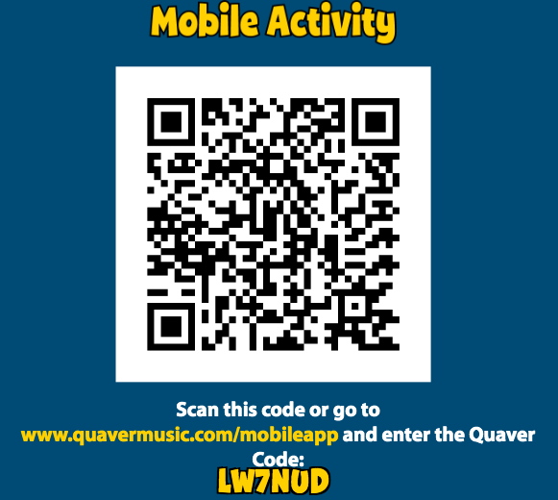 | Technology  Story Games  https://www.abcya.com/games/category/story  Please choose and story to listen or read and do the activities. | Library  Read something that’s not a book. Examples: recipe, magazine, newspaper, poem, etc.
PE  https://www.youtube.com/user/CosmicKidsYoga  Cosmic Kids Yoga  Yoga & Mindfulness  Designed for Kids | Music  Draw a picture based on a song that you’ve listened to. | Technology  Typing Games  Play against others to improve your typing skills.  https://www.freetypinggame.net/ | Library | PE  https://www.youtube.com/watch?v=8df2skF8gnQ  Chicken Fat Song  (2020)

